

Structural Transformation and Economic Growth
Larger Research Grants (LRGs)

Project Title

Contract Number: STEG_LOA_xxxx_xxxx

Contents

1. Definitions 4
2. Duration 6
3. Scope 6
4. Payments 6
5. Reporting 7
6. Use of Funds 8
7. Value for Money 11
8. Transfer of Funds 11
9. Governance 11
10. Research Ethics 12
11. Open Access 12
12. Media 12
13. Publication and Acknowledgement of Support 12
14. Staff 13
15. Equipment 13
16. Changes to the Consortium 13
17. Change of Principal Investigator and or Co-Investigator 13
18. Changes in Research Project 14
19. Transfers of Funds between Fund Headings 14
20. Liabilities and Insurance 14
21. Conflict of Interest 15
22. Security 15
23. Fraud 15
24. Counter-terrorism 16
25. Safeguarding 16
26. Force Majeure 16
27. Audits 16
28. Contact Details 17
29. Transparency 17
30. Data Protection 17
31. Extensions 17
32. Survival of Obligations 18
33. Severability 18
34. Termination of the Agreement 18
35. Future STEG Funding 19
ANNEXES 20
Annex I – Project Abstract 21
Annex II - Budget 22
Annex III – Financial Report Template 23
Annex IIII – Transfer of Funds Form 24

Contract

The Centre for Economic Policy Research (CEPR), established at 2 Coldbath Square, London, EC1R 5HL, United Kingdom (hereafter the Contractor),

And

[Contractee full official name (short name)][legal form], [official registration No], established in [official address in full] [VAT number – EU registered organisations only], (hereafter the Contractee)

have agreed to the following terms and conditions within the context of the research programme ‘Structural Transformation and Economic Growth’ (STEG), which is a research initiative funded by the Foreign, Commonwealth & Development Office (FCDO).

The Contractee agrees to these terms and conditions on behalf of the following legal entity(ies) (hereafter Partner Institution[s]) with whom it will carry out the work:

[full official name (short name)][legal form], [official registration No], established in [official address in full] [VAT number – EU registered organisations only],

1. Definitions

Access and Data Management Plan: a plan to outline the strategy for maximising opportunities to make research outputs open access, both during the Contract dates and for permanent digital access following the Contract End Date. It should also include estimated costs. A template can be found in FCDO’s Open Access policy.

CEPR’s Conflict of Interest Policy: means CEPR’s Conflict of Interest Policy found here: https://cepr.org/research/research-policies/conflict-interest-policy

CEPR’s Fraud, Bribery and Corruption Policy: means CEPR’s Fraud, Bribery and Corruption Policy found here: https://cepr.org/research/research-policies/fraud-bribery-and-corruption-policy

CEPR Privacy Policy: means CEPR’s Privacy Policy found here: https://cepr.org/privacy-policy.

Conflict of Interest: definition stated in CEPR’s Conflict of Interest Policy.

Contract/Agreement: this document, which is the binding agreement between the Contractor and Contractee consisting of all schedules, deliverables, timings, payments and any other terms and conditions specified by the Contractor.

Contractee: the institution with whom the Contractor enters into the Contract.
Contractor: the Centre for Economic Policy Research (CEPR).

Data Acquisition: means activities related to the acquiring or collecting of data as well as the handling and secure storage of data, which may include the purchasing of data or the conducting of surveys by an external party, where no such expertise exists at the Contractee or any Partner Institution.

FCDO’s Open Access policy: means the FCDO Research Open and Enhanced Access. Policy V1.1 available here: https://assets.publishing.service.gov.uk/government/uploads/system/uploads/attachment_data/file/181176/FCDOResearch-Open-and-Enhanced-Access-Policy.pdf.

Equipment: means tools needed for data collection including tablets, stationary and printing if not already available to the Contractee from other sources. It is expected that researchers and institutions will provide their own IT equipment such as tablets, mobile phones, laptops and computers for the duration of the project. In exceptional circumstances, these can be included in the budget but strong justification will need to be provided.

External Consultant: means experts not based at the Contractee or Partner Institutions who can provide demonstrable added value to the project’s objectives and results. They must also be justified to the Scientific Committee as scientifically necessary for the execution of the project.

Force Majeure: means any unforeseeable and exceptional situation or event beyond the control of the Contractee and Contractor which prevents either of them from performing any of their obligations under the Contract; that was not due to error or negligence on their part or on the part of a subcontractor or Partner Institution; and that could not have been avoided by the exercise of due diligence. Defects in equipment or material or delays in making it available, labour disputes, strikes or financial problems cannot be invoked as force majeure unless they stem directly from a relevant case of force majeure.

Malicious Software: commonly known as malware, is any software that brings harm to a computer system. Malware can be in the form of worms, viruses, trojans, spyware, adware and rootkits, etc., which steal protected data, delete documents or add software not approved by a user.

Partner Institution: legal entities with which the Contractee will carry out the Project. Partner Institutions are different from Subcontractors in that they are subject to all conditions specified in this Contract and manage their own independent budget as part of the Contract.

STEG Budget Guidelines for Larger Grants: means the most recent version of the STEG Budget Guidelines for Larger Grants found on the STEG website.
STEG Code of Conduct for Researchers: means the Code of Conduct for Researchers found on the STEG website: https://grp.guqq2.upcloudobjects.com/dev/s3fs-public/2026-01/GRP_Code%20of%20Conduct%20for%20Researchers.pdf

Project: the research that the Contractor will fund and the Contractee will undertake during the course of the Contract.

R4D: means Research for Development Outputs, the platform where outputs from FCDO’s funded research projects and programmes are available: https://www.gov.uk/FCDO-research-outputs.

Research Consortium Management Group: means the group of individuals responsible for overseeing and managing STEG, and make decision regarding the progress of Contractee’s Projects. The Committee is chaired by Douglas Gollin, the STEG Research Director.
Stipend and Salary: means the remuneration for work performed by research personnel for the duration of the Project in accordance with institutional employment contracts (where applicable).
Value for Money (VfM): means maximising the impact of each pound spent to improve the lives of those in low-income countries. It does not simply mean minimising costs but making judgements about expected impact compared to the required cost. VfM considerations will be applied to any transfer of funds and budget iterations by the Contractee.

2. Duration

The duration of the Project shall be xx months, starting on day month year (Project Start Date) to day month year (Project End Date).

3. Scope

The Contractor agrees to grant a financial contribution for the purpose of implementing the project “Title of the Project” (hereafter the Project) led by PI NAME (institution). Co-Investigator name (institution) shall also participate in the project as Co-Investigator(s). The maximum financial contribution shall be £xxx,xxx (IN WORDS – USE CAPITALS) as per the agreed budget (Annex II), which will include indirect costs not exceeding 20% of any eligible direct costs incurred and reported by the Contractee and its Partner Institution(s). The actual financial contribution shall be calculated on the basis of financial reports submitted by the Contractee and approved by the Contractor.

4. Payments

The Contractee agrees to be paid according to the following schedule:

- The first instalment will be paid no later than two months after signature of this Agreement corresponding to 50% of the total sum;
- The second instalment to be paid after delivery and approval of the first interim report (at 7 months) corresponding to 25% of the total sum;
- The third instalment to be paid after the delivery and approval of the second interim report (at 13 months) corresponding to 10% of the total sum;
- the remaining balance of up to 15% of the total sum shall be paid upon receipt of the final report and based on evidence of actual costs incurred provided in the final financial report to be submitted according to the schedule in Article 5. This final instalment will be paid no later than two months after the submission of the final report.

The Contractor reserves the right to modify the payment schedule, according to the Project’s requirements.
The maximum financial contribution shall not exceed the amount specified in Article 3 and the final payment will be based on total actual expenditure by the Contractee at the end of the Project. The Contractor reserves the right to withhold funds or request that funds are reimbursed, should the funds disbursed exceed the actual expenditure. The Contractor reserves the right to withhold payment if receipts are not provided or if the Contractee does not provide adequate proof of expenditure.

The parties acknowledge and agree that the funding provided under this Agreement is contingent upon confirmation and continued availability of funding from the UK Foreign, Commonwealth & Development Office ("FCDO"). In the event that such funding is not received or is subsequently withdrawn, CEPR may need to pause or discontinue funding under this Agreement.

Should such circumstances arise, CEPR reserves the right to terminate this Agreement. In doing so, CEPR will make all reasonable efforts to honour the Contractee’s existing commitments made in good faith prior to the withdrawal or non-confirmation of funding and will engage with the Contractee to agree on a reasonable phasing out of activities, where practical.

While CEPR will endeavour to minimise any negative impacts, it shall not be held liable for any costs, losses, or damages incurred by the Contractee as a result of the non-receipt or revocation of funding or the early termination of this Agreement.

5. Reporting

The Contractee agrees to submit a narrative and financial report for the duration of the Project covering the following periods:

- Interim Report 1: covering month 1, that is xx/xx/xxx to month 6, that is xx/xx/xxx (first period) and to be submitted by the end of month 7, that is xx/xx/xxxx;
- Interim Report 2: covering month 7, that is xx/xx/xxx to month 12, that is xx/xx/xxx (second period) and to be submitted by the end of month 13, that is xx/xx/xxxx;
- Interim Report 3: covering month 13, that is xx/xx/xxx to month 18, that is xx/xx/xxx (third period) and to be submitted by the end of month 19, that is xx/xx/xxxx;
- Final Report: covering month 19, that is xx/xx/xxx to month 24, that is xx/xx/xxx (final period) and to be submitted within one month of the Project End Date.

The narrative report will include a description of activities to date and a description of planned activities for the next reporting period. The financial report will include a full breakdown of expenditure over the reporting period and projected expenditure to be incurred in the following period. Figures must be provided for each budget line, not only budget category, as per the example expenditure in Annex III, which shows the financial report template that will be emailed to the Contractee one month prior to each reporting deadline. Scanned receipts and proof of expenditure against all items for the reporting period, including personnel costs, will be requested from the Contractee and any Partner Institution(s). With every interim report, the Contractee is required to submit an updated budget timeline to indicate projections for the remainder of the Contract.

All currency conversions in financial reports must be done using Oanda conversion rates. The exchange rate of the day the cost was incurred (i.e. the date on your receipts) should be used. Alternatively, the exchange rate of the final working day of the interim period may be used.

In the case of the Final Report a full breakdown of the expenditure over the project duration will be required in the financial report, again with scanned receipts and proof of expenditure against all items for the final period, including personnel costs, from the Contractee and any Partner Institution(s).

The Contractee also agrees to submit a draft research note with the Final Report and a final paper and links to, and copies of, working papers and datasets and any revised versions when they become available

The Contractee agrees to submit the above deliverables by the deadline set by the Contractor. Any delays must be agreed in advance with the Contractor as soon as they become apparent and no later than 2 weeks before a reporting deadline. Any extension to reporting deadlines may be granted at the discretion of the Contractor and is therefore not guaranteed. The Contractor reserves the right to suspend further payments and place the Project on a formal warning if reporting is excessively delayed; this decision will be taken by the Scientific Committee, which will also request a new proposal and timescale from the Contractee on how it will fulfil all its contractual requirements. If no appropriate action is taken by the Contractee to the satisfaction of the Scientific Committee and the Project remains on the formal warning status for another three months, the Contractee will be required to pay back all funds received to date from the Contractor.

6. Use of Funds

Grant funds must contribute towards the costs of the research for which the funds were awarded and be in accordance with the STEG Budget Guidelines for Larger Research Grants. Indirect costs, such as staff salary overhead and other staff-related costs as well as the costs associated with facilities and basic utilities, the purchase and repair of office equipment, administration fees, and basic communication devices such as telephones and fax machines, will be reimbursed up to a maximum of 20% of direct costs.

Funds must be used effectively and economically and any expenses incurred must be essential for the research for which the funds are awarded.
Please note that no additional funds will be made available to grantees to cover exchange rate losses or transaction costs over the course of the grant.

Costs incurred before the Project Start Date or after the Project End Date are not eligible.
Eligible Direct Costs (refer to STEG Budget Guidelines for Larger Research Grants document for more information).
- Stipend and salary costs;
- Staff training costs for field staff where this training is absolutely essential for the purpose of the Project and when justified in the Project proposal;
- Equipment and consumable costs;
- Travel and accommodation costs in line with HMRC worldwide subsistence rates (https://www.gov.uk/guidance/expenses-rates-for-employees-travelling-outside-the-uk);
- Costs of developing and maintaining a project website;
- Costs associated with the dissemination of findings including costs associated with ensuring open access (e.g. costs of publishing in an open access journal or making a journal article open access);
- Costs associated with the organisation of workshops or seminars, the activities of which relate directly to the dissemination of the funded research;
- External consultants’ costs, which must have been specifically referred to and described in detail in the proposal relating to the Project and required only in relation to the Project’s core research activities (as set out in Annex II) and where such expertise does not exist in-house at the Contractee or any of its Partner Institutions;
- Fieldwork costs including local transportation costs only with prior approval from the Contractor;
- Data collection costs. Any costs related to Data Acquisition and in line with the STEG Budget Guidelines for Larger Research Grants. If any such activities are conducted by an external party (i.e. not affiliated to the Contractee nor any Partner Institution), they will be regarded as Subcontracting and will attract no indirect costs;
- Any other exceptional costs identified subsequent to this Contract coming into force and agreed to formally by the Contractor.
Non-Eligible Direct Costs
- Maintenance, insurance and safety costs;
- Common office equipment such as PCs, laptops, office software;
- Miscellaneous recurring consumables;
- Recruitment costs and staff training costs (not including field staff as per the conditions under Eligible Direct Costs);
- Indirect taxes, such as VAT;
- Provisions for future losses;
- Exchange losses and transaction fees;
- Excessive or reckless expenditure;
- Salary bonuses and benefits including fringe benefits.
Subcontracting Costs
Subcontracting costs may only cover the execution of a limited part of the Project and therefore cannot relate to any core activities of the Project (except any relating to data acquisition and handling included and justified in the proposal), and any subcontractor engaged by the Contractee must be a legal entity. Where the Contractee has identified the need to engage the services of an external party (i.e. one not identified in this Contract) to carry out work necessary for successful completion of one or more of the Project’s deliverables and for which costs have been identified in Annex II to this Contract (the budget), the Contractor will permit costs for this to be incurred directly by the Contractee only and not exceeding 30% of its financial contribution to the Project as set out in Article 3 above. Should costs exceed 30% of the financial contribution to the Project, the external party must be included as a Partner Institution in this Contract. Partner Institutions are permitted to claim indirect costs not exceeding 20% of their own eligible direct costs. However, the Contractee is not permitted to claim indirect costs on Partner Institution’s direct costs. The Contractee and Partner Institutions cannot charge indirect costs on work subcontracted to an external party, including External Consultants.
Change this article if Co-ordinator and Partner have special overhead agreement
The Contractee must seek formal approval from the Contractor for any subcontracting in advance of any costs being incurred if any work to be carried out originally by the Contractee or any Partner Institution can no longer be undertaken by them due to staffing changes or lack of in-house expertise. A full scientific justification must be submitted by the Contractee to the Contractor at least two calendar months before the work is to be carried out. The Contractee is obliged to invite tenders for any work to be subcontracted to another party according to its usual practices and to provide details to the Contractor of the total costs along with the full scientific justification as part of the formal request for these costs to be subcontracted, which must be in line with the VfM criterion referred to in Article 7 of this Contract.
The Contractee will need to ensure that any costs for subcontracting will be related solely to the provision of work contributing to the Project and not to cover costs such as the purchasing, installation and maintenance of computers and equipment.
The Contractee assumes full responsibility for the delivery of any work to be carried out by the Subcontractor and will ensure that any relevant provisions contained in this Contract are reflected in its agreement with the Subcontractor.

7. Value for Money

Value for Money (VfM) is a very important criterion in STEG projects. In this respect, the Contractee would be expected to be able to explain and justify all costs in terms of why they are considered to be ‘best value’ and to explain the process by which they have arrived at that conclusion. We would also expect the Contractee to pass on their understanding of VfM to Partner Institution(s) which may be involved in the project, and to undertake the same level of scrutiny with regard to the Partners' justification and explanation of costs.
It should also be noted by the Contractee and Partner Institutions that, in addition to VfM, receipts or proof of expenditure should be retained against all expenditure items, including personnel costs, claimed during the Contract period and provided to the Contractor upon request. (See also Article 27 Audits).

8. Transfer of Funds

Funds shall be transferred in pounds sterling. The Contractor is not responsible for any loss incurred through fluctuations in exchange rates and/or any transaction fees incurred by the Contractee.
The Contractee is responsible for the transfer of the STEG grant funds to the Partner Institution(s) of the Project. Each Partner Institution must complete a Transfer of Funds Form (Annex IIII) for each transfer of funds received. The Contractee should return a copy to the Contractor.

9. Governance

It is the responsibility of the Contractee to ensure that the research is conducted in accordance with the highest standards of scientific integrity and research methodology.

The Contractee should also ensure that the roles and responsibilities of Partner Institutions are clearly defined.

The Contractor requires that the Contractee establishes a Consortium Agreement prior to the commencement of the Project with the Partner Institution(s) that is agreed and signed by all members.

A copy of this agreement must be made available to the Contractor within two months of the Project Start Date.

The Contractee shall be held legally accountable for the allocation of funds to Partner Institutions within the consortium.

10. Research Ethics

The Contractee will adhere to the terms of the STEG Code of Conduct for Researchers. Ethical issues relating to the research project, as defined in the STEG Code of Conduct for Researchers, must be clearly identified. Approval to undertake the research must be sought before any work requiring ethical approval commences.

11. Open Access

FCDO is committed to strengthening demand for knowledge and improving access to research information. A copy of FCDO’s Open Access policy will be provided to grant holders under the STEG project. Grant holders are required to adopt the policy and to maximise the use of open access publication wherever possible.

FCDO also requires grant holders under the STEG project to:
- Archive quantitative and qualitative data sets, resulting from the research it funds, with appropriate data archiving repositories at the earliest opportunity
- Submit datasets to CEPR
- Retain the raw datasets for a minimum of five years
- Deposit the metadata on the R4D section of FCDO’s website via CEPR
- Deposit reports and other written material in R4D via CEPR
- Make all peer-reviewed journal articles arising from the project open access
FCDO and the Contractor will jointly monitor the extent of open access publication as part of project monitoring. Contractees are required to create an Access and Data Management Plan for their project and submit to the Contractor by month 7, that is xx/xx/xxxx.

Failure to comply with the requirements set out in this Article, including the timely submission of datasets, may be taken into account in the assessment of the Contractee’s eligibility for future funding under the STEG programme and other FCDO funded programmes administered by the Contractor.

12. Media

The Contractee should agree the content of any media statements, if required, with the Contractor and/or FCDO prior to publication.

The use of the STEG, CEPR or FCDO logos must be agreed with the Contractor and FCDO on a case-by-case basis.

13. Publication and Acknowledgement of Support

The Contractee shall retain all rights to the work produced under this Agreement. Upon production of any such work, the Contractee shall automatically grant the Contractor an irrevocable, worldwide, royalty-free, non-exclusive licence to use, reproduce, publish or re-publish, or otherwise disseminate such copyrighted work. The Contractor shall credit the Recipient’s authorship on all copies of the works that are disseminated. In view of the support provided, the Contractee shall also undertake to mention the financial assistance received in the publication of their research.

Any publication that results from the Project shall contain the following acknowledgement:

“This document is an output from the research initiative ‘Structural Transformation and Economic Growth’ (STEG), a programme funded by the Foreign, Commonwealth & Development Office (FCDO), contract reference STEG_LOA_xxxx_xxxx. The views expressed are not necessarily those of FCDO.”

The Contractee takes full responsibility for ensuring that Partner Institution(s), Subcontractors and External Consultants also use the STEG acknowledgement in any related publication.

14. Staff

The Contractee assumes full responsibility for staff funded through the STEG grant.

The Contractee agrees to undertake all responsibilities for these staff, including their terms and conditions of employment and their training and supervision arising from the employer/employee relationship. Staff must be appointed on terms that are no less favourable than those of comparable posts in the Contractee’s organisation.

15. Equipment

Equipment purchased from grant funds is primarily for use on the research Project for which the research grant was awarded and belongs to the Contractee.

After the end of the project, the Contractees may use the equipment without reference to STEG.

16. Changes to the Consortium

Any amendments required to the composition of the Consortium must be discussed in advance and approved by the Contractor.

The Contractor will consider such changes provided they do not change the essential character of the project.

17. Change of Principal Investigator and or Co-Investigator

The Contractee must consult the Contractor should it deem it necessary to change the Principal Investigator and/or Co-Investigator.

The Contractor reserves the right to ensure that the new Principal Investigator and/or Co-Investigator meets the eligibility criteria and has the expertise and experience to lead the Project to a successful conclusion, in accordance with its research objectives.

18. Changes in Research Project

The Contractor must be consulted in the event of any major planned or actual deviation from the proposed research Project (including failure to gain access to data) that will have an impact on the objectives of the Project. If appropriate, revised proposals may be required.

19. Transfers of Funds between Fund Headings

The transfer of funds is permitted only between direct costs. Funds may be transferred only for the costs of activities that meet the agreed objectives of the Project.

Transfers of funds between budget headings are permitted, with no approval needed, within a range of 20% of the original funds allocated to the heading over the entire duration of the Contract. For transfers over 20%, the Contractee must submit a formal justification to the Contractor for approval including the scientific reason for the transfer and any impacts on the research outcomes. The Contractee must have received approval from the Contractor before changes to the project are implemented.

20. Liabilities and Insurance

Each Partner Institution (including the Contractee) fully guarantees the Contractor and agrees to indemnify it in case of any action, complaint or proceeding brought by a third party against the Contractor as a result of damage caused, either by any of its acts or omissions in relation to this Contract, or by any products, processes or services created by it on the basis of results of the Project.

Each Partner Institution (including the Contractee) shall bear sole responsibility for ensuring that their acts within the framework of this Project do not infringe third parties’ rights. This should be set out in the Consortium Agreement to be signed between the Contractee and the Partner Institutions.

Unless otherwise specified by the Contractor, the Contractee shall, with effect from the Project Start Date, take out and maintain with a reputable insurance company a Professional Indemnity Insurance providing an adequate level of cover in respect of all risks which may be incurred by the Contractee, arising out of the Contractee’s performance of its obligations under the Contract. Such insurance shall be maintained for the duration of the Contract Period and for a minimum of six (6) years following the expiration or earlier termination of the Contract.

The Contractee shall give the Contractor, on request, copies of all insurance policies referred to in this clause or a broker’s verification of insurance to demonstrate that the appropriate cover is in place, together with receipts or other evidence of payment of the latest premiums due under those policies.

Funds from the project may not be used for the purchase of such Professional Indemnity Insurance cover.

21. Conflict of Interest

The Contractee shall take appropriate steps to ensure that neither the Contractee nor any Partner Institution(s) are placed in a position where there is or may be an actual or potential conflict between the financial or personal interests of the Contractee and the duties owed to the Contractor and the STEG Programme under the provisions of the Contract. The Contractee will notify the Contractor without delay, giving full particulars of any such Conflict of Interest which may arise.

The Contractee will also abide by the principles and guidelines stipulated in CEPR’s Conflict of Interest Policy.
The Contractor reserves the right to terminate the Contract immediately by notice in writing and/or to take or require the Contractee to take such other steps it deems necessary where, in the reasonable opinion of the Contractor, there is or may be an actual or a potential conflict between the financial or personal interests of the Contractee and the duties owed to the Contractor and the STEG programme under the provisions of the Contract.

22. Security

The Contractee shall, as an enduring obligation throughout the Contract, use the latest versions of anti-virus definitions available from an industry accepted anti-virus software vendor to check for and delete Malicious Software.

Notwithstanding the above, if Malicious Software is found, the Contractee shall endeavour to reduce the effect of the Malicious Software and, particularly if Malicious Software causes loss of operational efficiency or loss or corruption of data, endeavour to mitigate any losses and to restore the provision of services to their desired operating efficiency.

23. Fraud

The Contractee will adhere to the terms of CEPR’s Fraud, Bribery and Corruption Policy.

Where, after the award of the Contract, the Contractee is proven to be involved in fraudulent activities, the Contractor may refuse to make payments, may recover amounts already paid or may terminate the contract, in proportion to the irregularities of fraud.

FCDO and CEPR have a zero-tolerance approach towards fraud and fraudulent behaviour that may lead to the misuse of funds. In the event of any credible indications that STEG funds may have been subject to fraud, FCDO, may, at any time during the period of this Contract and up to five years thereafter, arrange for additional fraud investigations, on-the spot checks and/or inspections to be carried out. These may be carried out by FCDO, or any of its duly authorised representatives.

24. Counter-terrorism
Consistent with numerous United Nations Security Council resolutions, the Contractee and Contractor are firmly committed to the international fight against terrorism. The Contractee will ensure that none of the funds committed will be used to provide support to individuals or entities associated with terrorism.

25. Safeguarding
The Contractee confirms that it:
- will provide a safe and trusted environment which safeguards anyone with whom Contractee has contact with, including beneficiaries, staff and volunteers;
- will promote an organisational culture that prioritises safeguarding to ensure it is safe for those affected to come forward, and to report incidents and concerns with the assurance that they will be handled sensitively and properly;
- has adequate safeguarding policies, procedures and measures to protect beneficiaries, staff and any volunteers and that these are shared and understood;
- has absolute clarity as to how incidents and allegations will be handled should they arise, including reporting to the relevant authorities and to Contractor.
At time of signing this Contract, the Contractor confirms it has not been required to report any such incidents to any relevant authorities. However, should any future concerns arise, the Contractee will be immediately reported to the relevant authorities by the Contractor, with due diligence.

26. Force Majeure
Should the Consortium or the Contractor be faced with Force Majeure, they shall notify the other party without delay by registered letter stating the nature, likely duration and foreseeable effects.

Neither contracting party shall be held in breach of its contractual obligations if it has been prevented from performing them by Force Majeure. Where the Contractee is unable to perform his contractual obligations owing to Force Majeure, it shall have the right to remuneration only for tasks actually executed.

27. Audits
The Contractee should retain information pertaining to the Project for the duration of the grant and for six (6) years thereafter. Such information should include (where applicable):

- original receipts
- original invoices
- contractual documentation with 3rd parties
- salary evidence (timesheets and/or payslips)

The Contractee should permit unrestricted access to the Contractor upon request and reasonable notice (no less than two months’ notice) to look at and copy any relevant documentation pertaining to the Project that the Contractor may require.

Prior to the signature of this Contract, the Contractee should provide the Contractor with a copy of their organisation’s annual audited accounts. Another copy that demonstrates and records the use of funds relating to the Project should be provided six months after the Project End Date. Should this not be possible to demonstrate via the audited accounts, a letter from the organisation’s independent auditor must be provided by the Contractor that verifies the income and expenditure incurred against the Project for each financial year in which the Project falls.

Should the Contractor request an external audit of the Project, all costs will be borne by the Contractor.

28. Contact Details
The Contractor must be informed of any changes to the Contractee’s or Principal Investigator’s contact details, including email addresses, during the contract period and six (6) years thereafter.

29. Transparency
The Contractor is permitted to publish financial data related to the Contract on the International Aid Transparency Initiative website. Data will include the amount transferred to the Contractee, the name of the Contractee and the date of the transfer. No personal information such as individual’s names, grant number and contact details will be included. More information can be found here: https://iatistandard.org/en/

30. Data Protection
When processing personal data, the Contractor complies with all applicable United Kingdom Data Protection Laws and the CEPR Privacy Policy.

The personal data the Contractor collects will be used for grant management purposes only. The Contractor will not disclose the Contractee’s personal data to third parties, unless:
- It is due to a lawful request under United Kingdom law e.g. a court order;
- It is to protect the Contractor or enforce our rights in the event of a dispute or security breach.

31. Extensions
The Contractee must formally request approval from the Contractor for an extension of the duration of the project no later than three months before the Project End Date set out in this Agreement. Extensions will be granted only in exceptional circumstances and requests should include an academic justification supported by projected expenditure covering the extension period proposed in addition to any of the remaining Project duration specified in Article 2 of this Agreement. Any extension request that is not as a consequence of Force Majeure will be allowed at the Scientific Committee’s discretion and is therefore not guaranteed. Any expenditure incurred beyond the Project End Date set out in this Agreement and where an extension is not approved, will not be eligible for reimbursement.

32. Survival of Obligations
The Contractee and Contractor’s obligations under this Agreement will be continuous and survive expiration or termination of this Agreement as expressly provided in this Agreement or otherwise required by law or intended by their nature, including, without limitation obligations relating to the acknowledgement of funding, submission of deliverables, open access, retention of data, and audit clauses.

33. Severability
Each provision of this Agreement must be interpreted in a way that is enforceable under applicable law. If any provision is held unenforceable, the rest of the Agreement will remain in effect.

34. Termination of the Agreement
Contractee’s initiative

The Contractee shall be entitled to request the termination of the contract by serving notice in written form to the Contractor. Any request for termination must be submitted by the Contractee, who will act on behalf of the Partner Institution(s).

The request for termination by one or more Partner Institutions, including the Contractee, must include:

- the reason for requesting the termination
- the proposed date of termination

Contractor’s initiative

The Contractor may terminate the contract or the participation of one or more Partner Institutions in the following cases:

- when one or more Partner Institutions does not accede to the contract;
- when one or more Partner Institutions has contravened fundamental ethical principles;
- in case of non-performance of the work stipulated in the contract;
- when the stipulated reports and deliverables have not been submitted to the Contractor;
- for contravening the financial regulations in the contract;
- when one or more Partner Institutions are found responsible for gross professional misconduct;
- when one or more Partner Institutions are declared bankrupt;
- where the Contractor has evidence that one or more Partner Institutions is involved in fraud, corruption or in criminal activities or any other illegal activity.

Termination of the participation of one or more Partner Institutions shall be notified to the Partner Institutions concerned, with a copy to the Contractee and shall take effect on the date indicated in the notification and at the latest 30 days after its receipt by the Partner Institution.

35. Future STEG Funding
Any breach of contract, including adherence to deadlines, may affect the ability of the Contractee to apply for future STEG funding.

36. Jurisdiction

If a dispute should arise during the course of this Agreement between the Contractor and the Contractee, all parties should resolve to settle the dispute amicably. If this fails the dispute will be settled according to the laws of England and Wales.

For the Contractor For the Contractee

Dr Tessa Ogden [Name]
Chief Executive Officer Title
CEPR Organisation
Date: Date:

ANNEXES

- PROJECT ABSTRACT
- BUDGET
- FINANCIAL REPORT TEMPLATE
- TRANSFER OF FUNDS FORM

Annex I – Project Abstract

Annex II - Budget
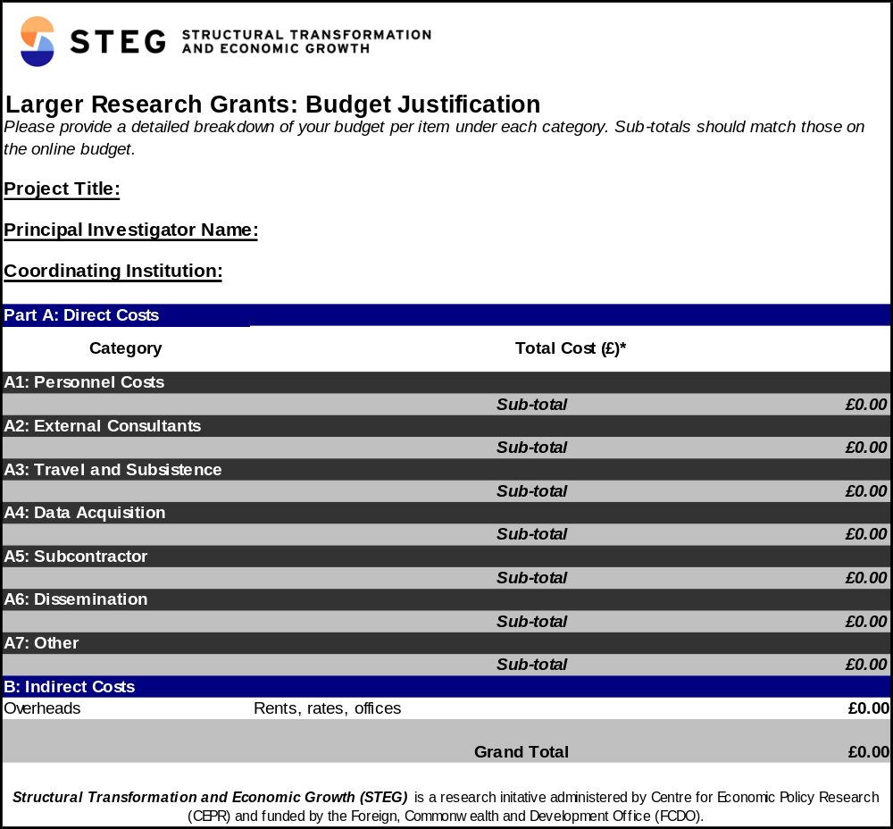

Annex III – Financial Report Template

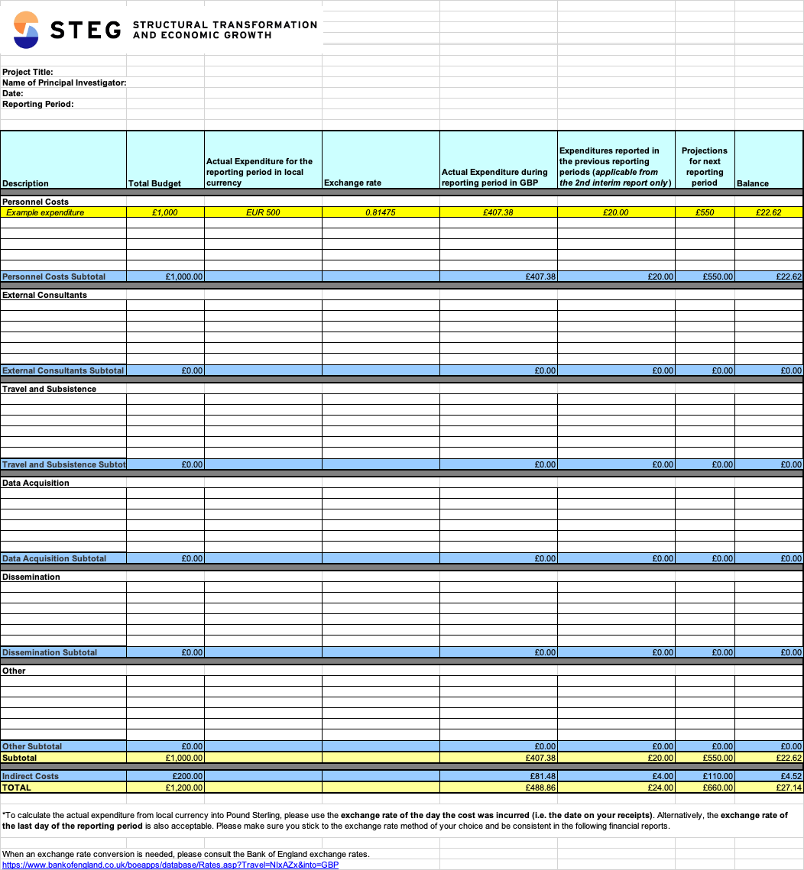

Annex IIII – Transfer of Funds Form

Transfer of Funds Form

Please complete and return and to CEPR

Project Title:
Start date of the project:
Partner Institution:

The Partner Institution acknowledges the receipt of funds and agrees to fulfil its role and responsibilities as identified in the STEG contract.

Amount transferred (£) …………………………………………………

Name of Legal Representative ………………………………………….

Signed ……………………………………………………………………

Date ………………………………………………………………………

Institutional Official Stamp:

